**Lab 6**

**Zelalem Gelgelo**

**109695**

1. **Gains, Inc. is a LLC that owns many companies.  Create an ER diagram for each of the following descriptions:**  
   1. 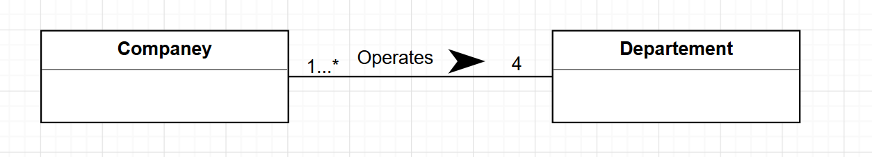Each company operates four departments, and each department belongs to one company.  
      ANS:
2. Each department in part (a) employs one or more employees, and each employee works for one department.  
   ANS:

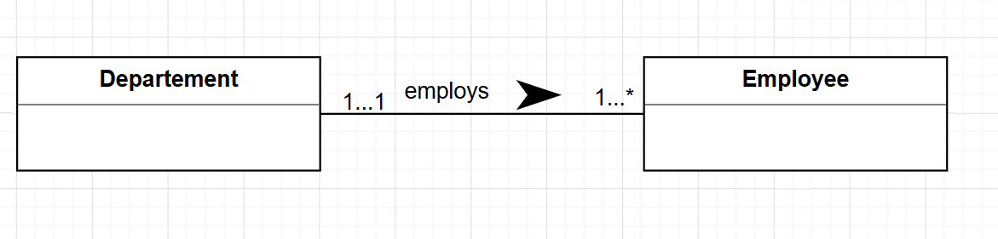

1. Each of the employees in part (b) may or may not have one or more dependents, and each dependent belongs to one employee.  
   ANS:

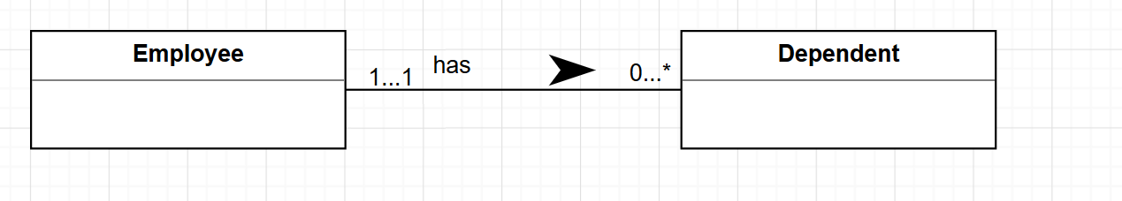

1. Each employee in part (c) may or may not have an employment history.  
   ANS:

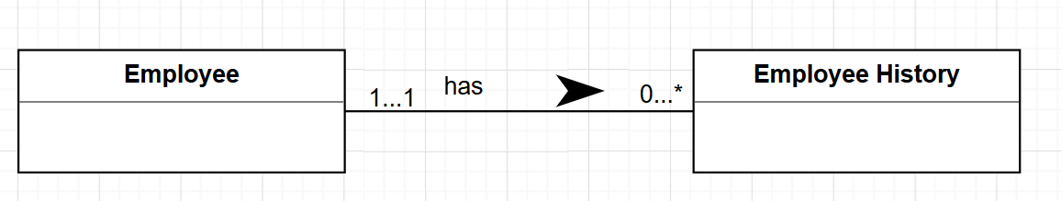

1. Represent all the ER diagrams described in (a), (b), (c), and (d) as a single ER diagram.  
   ANS:    
    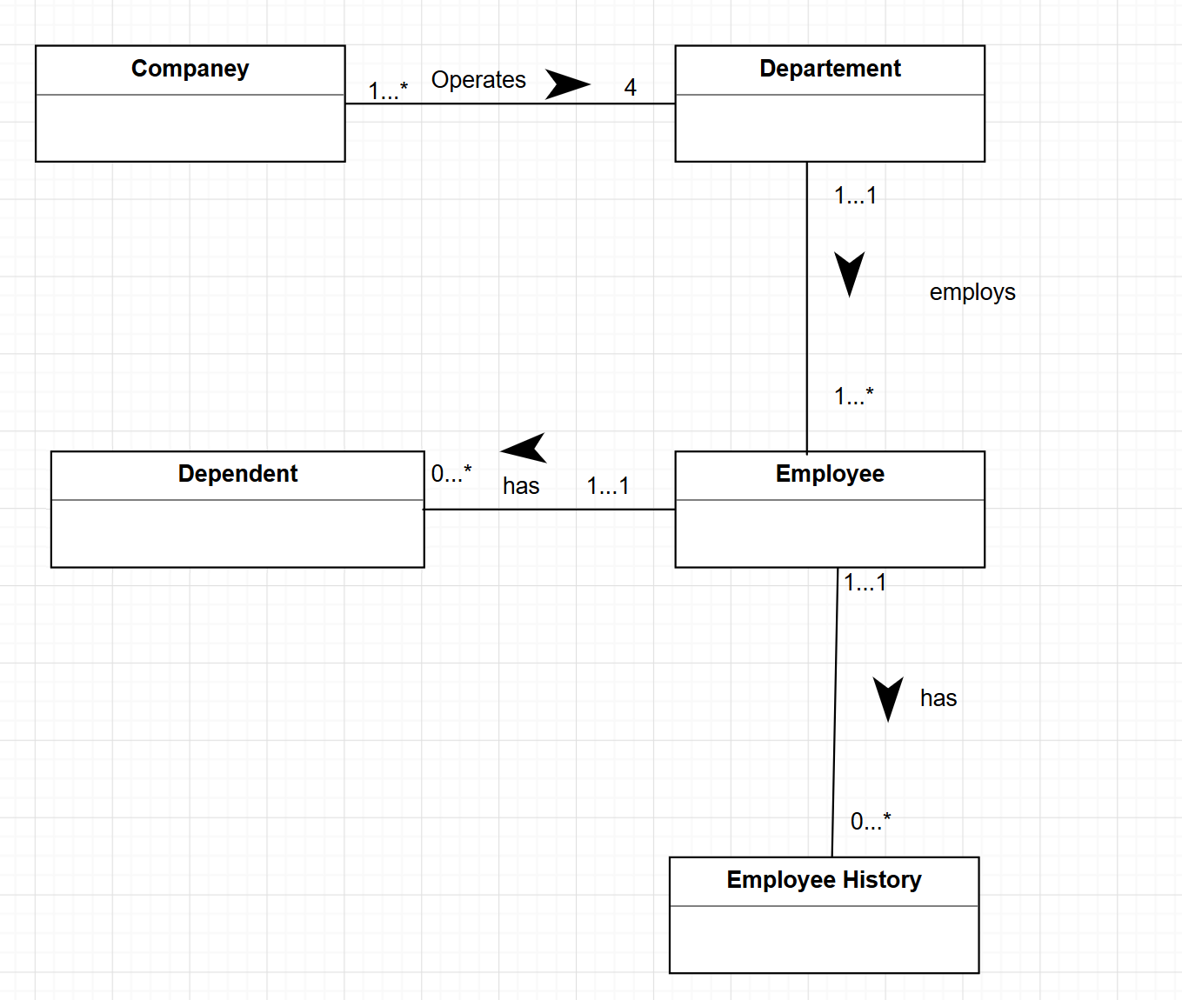

**2. Create an ER model based on the following descriptions.**

1. A patient can make many appointments with one or more doctors in the clinic and a doctor can accept appointments with many patients. However, each appointment is for a patient and is with one doctor.
2. If kept, an appointment yields a visit with the doctor specified in the appointment and that in turn results in a diagnosis and, when appropriate, treatment.
3. Each visit updates the patient’s medical history.
4. Each visit creates a bill.
5. A bill may be paid in many installments. However, each payment is properly recorded.
6. A patient can make payment by himself or through insurance company. If the insurance company pays, patient is responsible for the deductibles only.

ANS:

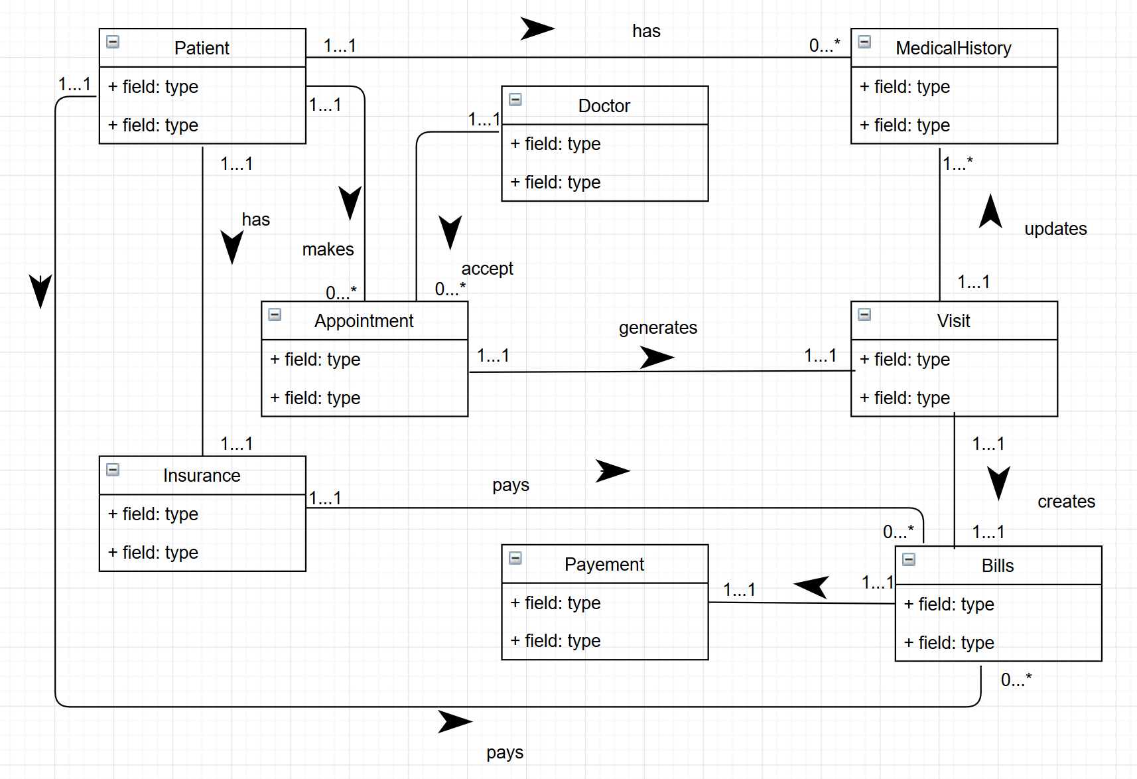

1. **Solve exercise 12.12 from the 6th edition (page 383).  If time permits, solve from *a-f*.  Otherwise, it’s ok if you just solve *f*.**  
   ANS:

# 

Video

catalogNo

Branch

branchNo

Staff

staffNo

VideoForRent

videoNo

RentalAgreement

rentalNo

Member

memberNo

Is

1..1

1..*

Registers

1..1

1..*

IsPartOf

1..1

0..*

Requests

1..1

0..*

Has

Manages

1..*

1..1

0..1

1..1

IsAllocated

1..1

1..*

Registration

Agrees

1..*

1..1

1..*